NOTICE
LIGHT RAIL TRANSIT 3 (LRT3) FROM BANDAR UTAMA TO JOHAN SETIA

Continuation of Road Closure and Traffic Diversions
on Jalan Batu Nilam, (Klang-bound)

Date | 1 January 2023 to 31 March 2023
Day | Monday to Sunday
Time | 24 hours
Reason | To facilitate LRT3 project-related works

The road closure and traffic diversions are as shown on the map below:

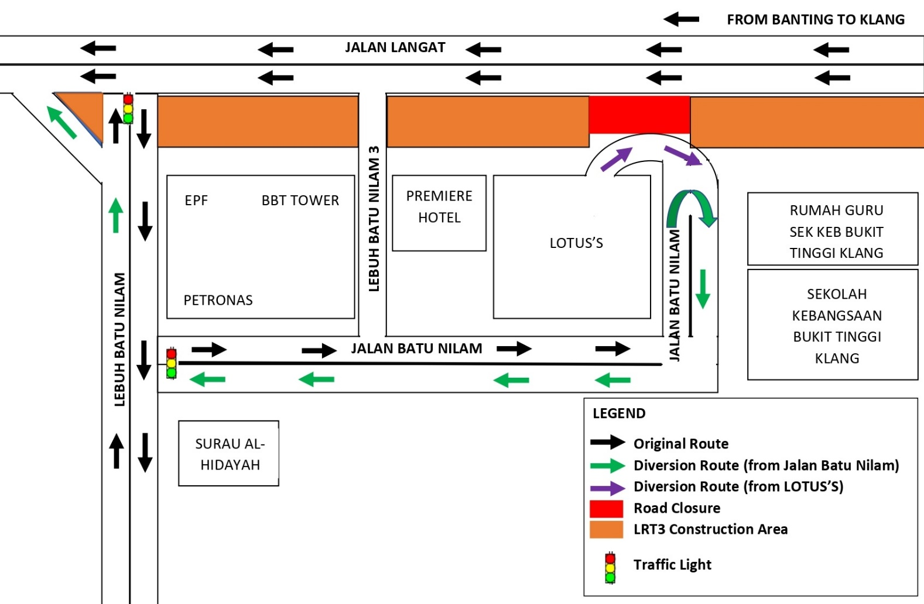

The diversions are implemented following the approval from the Majlis Perbandaran Klang (MPK).

We apologise for any inconvenience caused to the public and greatly appreciate your kind understanding and patience as we build LRT3 for the betterment of the future.

For more information, please contact:

Ahmad Khairulanuar, Project Manager : 019 - 262 5924
Saidatul Naquah, Executive Public Relation & Communications : 013 - 3017820

