NOTICE
LIGHT RAIL TRANSIT 3 (LRT3) FROM BANDAR UTAMA TO JOHAN SETIA

Lane Closures and Traffic Diversions on SPRINT Highway
(Damansara-bound/ Klang-bound)
from 3 January 2023 to 31 January 2023

Date | 3 January 2023 to 31 January 2023
Day | Monday to Sunday
Time | 11.30 pm to 5.00am
Reason | To facilitate LRT3 project-related works

The closure and traffic diversion are shown on the map below:
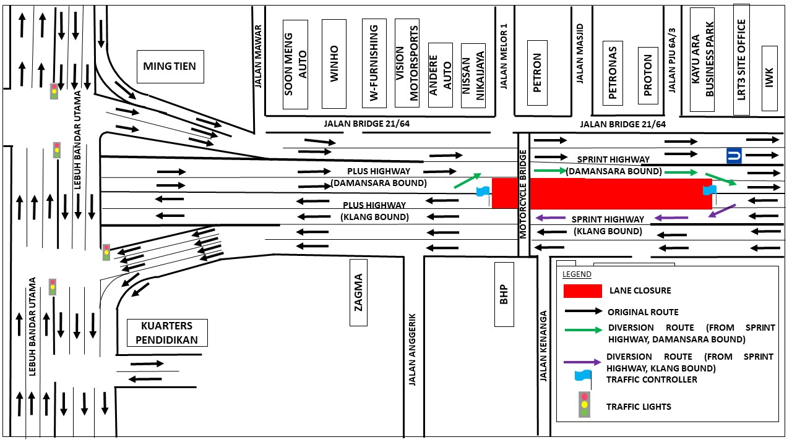
The diversions are implemented following the approval from Lembaga Lebuhraya Malaysia (LLM).

We apologise for any inconvenience caused to the public and greatly appreciate your kind understanding and patience as we build LRT3 for the betterment of the future.

For more information, please contact:

Vanessa Vivekananda, Senior Public Relations Manager : 019-2835815

