NOTICE
LIGHT RAIL TRANSIT 3 (LRT3) FROM BANDAR UTAMA TO JOHAN SETIA

Road Closure and Traffic Diversions
along Jalan Tropicana Selatan 1, Petaling Jaya

Date | 20 September 2021 to 31 December 2021
Day | Monday to Saturday
Time | 10.00 pm to 6.00 am
Reason | To facilitate LRT3 project-related works.

The closure and diversions are as shown on the maps below:

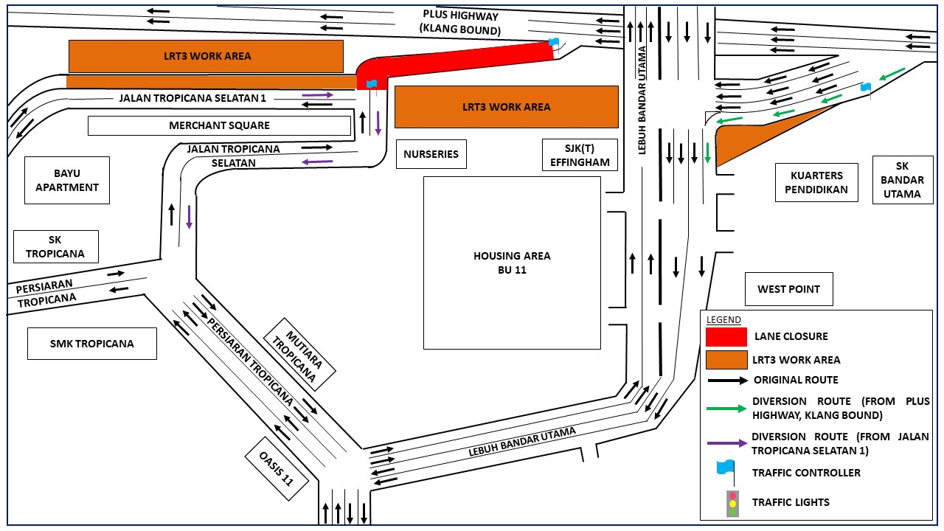
The diversions are implemented following the approval from Petaling Jaya City Council (MBPJ). Throughout the National Recovery Plan (NRP) Phase 2 period, we will be following the guidelines of the Ministry of International Trade and Industry (MITI) and the Ministry of Health (MOH) when carrying out our construction activities.

We apologise for any inconvenience caused to the public.

For more information, please contact:

Ong Ken Kee, Senior Project Manager : 019-6632139
Vanessa Vivekananda, Senior Public Relations Manager : 019-2835815

