NOTICE
LIGHT RAIL TRANSIT 3 (LRT3) FROM BANDAR UTAMA TO JOHAN SETIA

Lane Closure and Traffic Diversion
on SPRINT Highway (Damansara-bound)
from 16 August 2021 to 30 August 2021

Date | 16 August 2021 to 30 August 2021
Day | Monday to Sunday
Time | 24 hours
Reason | To facilitate LRT3 project-related works

The closure and traffic diversion are shown on the map below:
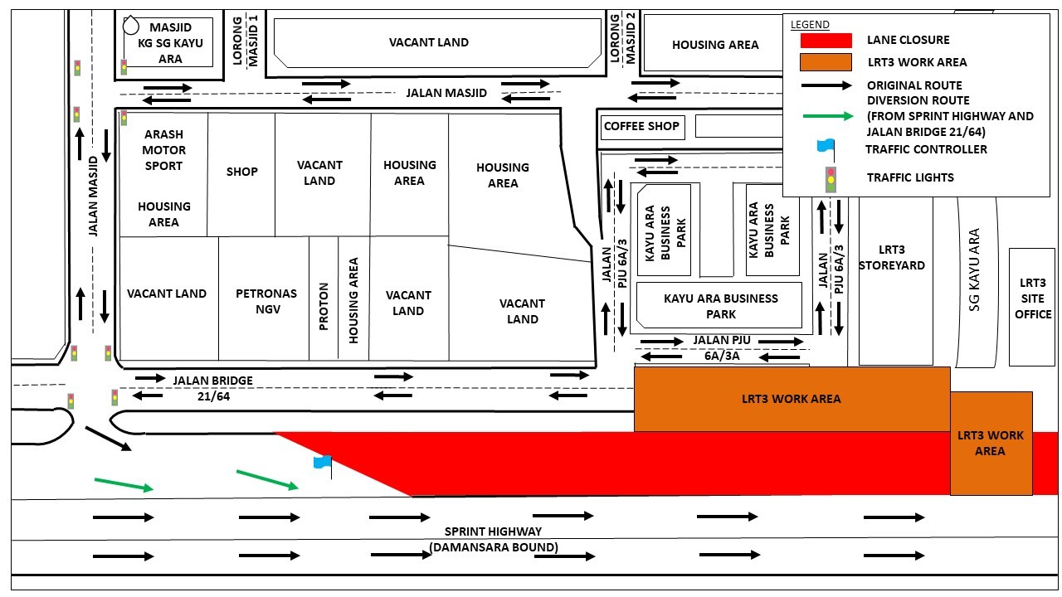
The diversions are implemented following the approval from Lembaga Lebuhraya Malaysia (LLM). Throughout the National Recovery Plan (NRP) Phase 1 period, we will be following the guidelines of the Ministry of International Trade and Industry (MITI) and the Ministry of Health (MOH) when carrying out our construction activities.

We apologise for any inconvenience caused to the public.

For more information, please contact:

Ong Ken Kee, Senior Project Manager : 019-6632139
Vanessa Vivekananda, Senior Public Relations Manager : 019-2835815

