NOTICE
LIGHT RAIL TRANSIT 3 (LRT3) FROM BANDAR UTAMA TO JOHAN SETIA

Road Closures and Traffic Diversions along Lebuh Bandar Utama, Petaling Jaya

Date | 25 May 2021 to 30 June 2021
Day | Monday to Friday
Time | 12:00 a.m. to 6:00 a.m.
Reason | To facilitate ‘U-Girder’ launching works

The closures and diversions are as shown on the maps below:

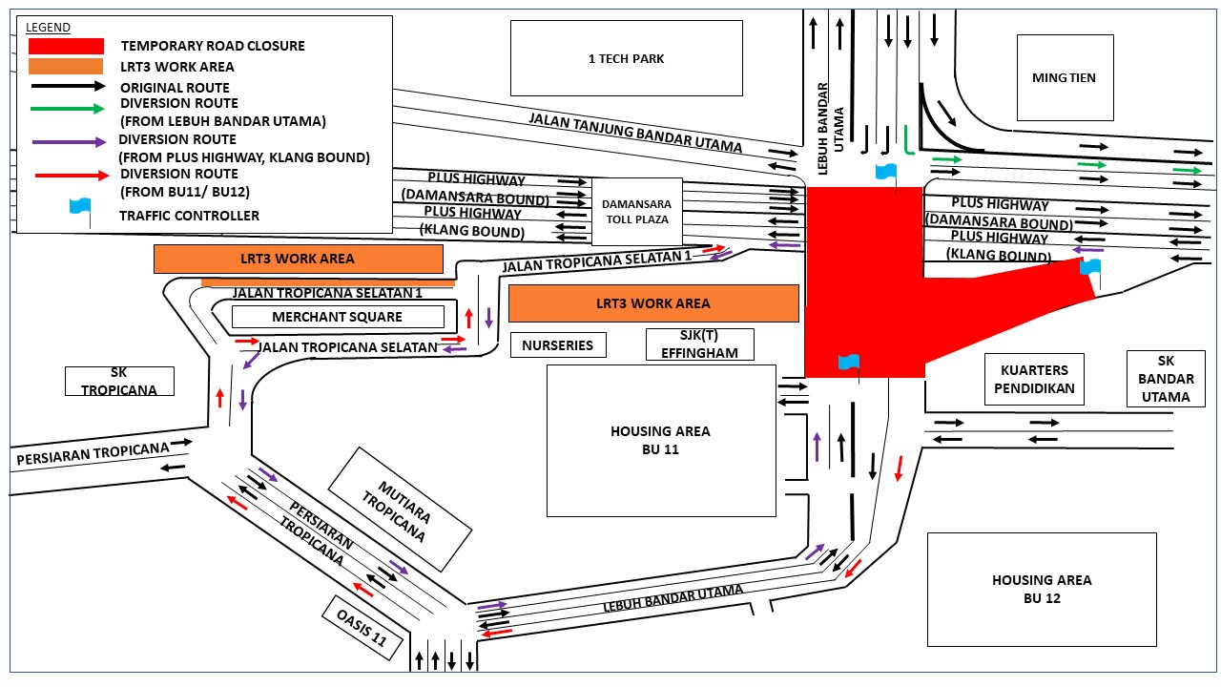

The diversions are implemented following the approval from Petaling Jaya City Council (MBPJ). Throughout the Movement Control Order (MCO) period, we will be following the guidelines of the Ministry of International Trade and Industry (MITI) and the Ministry of Health (MOH) when carrying out our construction activities.

We apologise for any inconvenience caused to the public.

For more information, please contact:

Ong Ken Kee, Senior Project Manager : 019-6632139
Vanessa Vivekananda, Senior Public Relations Manager : 019-2835815

