NOTICE
LIGHT RAIL TRANSIT 3 (LRT3) FROM BANDAR UTAMA TO JOHAN SETIA

Traffic Diversion at Jalan Meru, Klang
to facilitate LRT3 Telco Line Relocation (Time Dot Com)
from 20 to 30 August 2018

Please be informed that with the approval from Klang Municipal Council and Malaysian Public Works Department, there will be traffic diversion at Jalan Meru, Klang, to facilitate LRT3’s telco line relocation (Time Dot Com) starting from 20 August until 30 August 2018 for a duration of 11 days.

The traffic diversion are as follows:

Lane diversion at Jalan Meru, Klang: 20 – 30 August 2018 (24-hour)

Part of the most left lane on Jalan Meru from Panasonic Galaxy Strength Sdn Bhd until Pemborong Klang Li &Co Sdn Bhd will be closed (Klang/Banting - bound). Motorists who wish to turn left into Jalan Pasar Baru will be diverted as indicated by the GREEN arrows in the map:

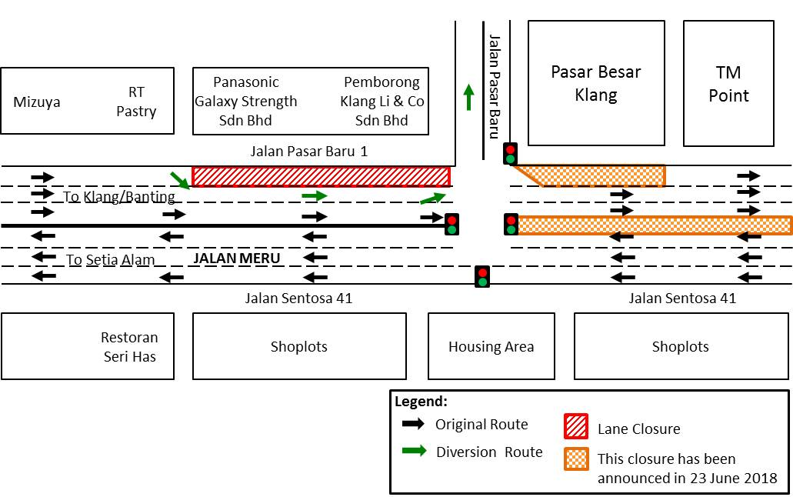

We apologise for any inconvenience caused to the public and greatly appreciate your kind understanding and patience as we build LRT3 for the betterment of the future, and in improving Klang Valley’s public transport system.

For more information :
Ms. Vanessa Song, Manager, PR & Stakeholder Management : 012 – 232 3782
Ms. Nadia Rosli, Executive, PR & Stakeholder Management : 017 – 388 9357

