Event Caption for event listing

Official Launching of LRT3 Project

LRT3 project has been officially launched by Prime Minister of Malaysia, Hon. Dato’ Sri Najib bin Tun Hj. Abdul Razak at Stadium Malawati, Shah Alam, Selangor Darul Ehsan on 24th August 2016. The event also was attended by Chief Minister of Selangor, Dato’ Seri Mohammed Azmin bin Ali; Chairman of Prasarana Malaysia Berhad, Tan Sri Ismail Adam; President & Group CEO of Prasarana, Dato’ Azmi Abdul Aziz; Minister of Transport, Dato’ Sri Liow Tiong Lai; Urban Wellbeing, Housing and Local Government Minister, Tan Sri Noh Omar; Selangor Exco, Teng Chang Khim; MRCB’s Chairman, Tan Sri Mohamad Salim Fateh; George Kent’s Chairman Tan Sri Tan Kay Hock and others.

An estimated 4,500 pax of guests arrived for the distinguished event, comprising of Prasarana employees, contractors and politicians. The launch begins with a welcome speech by the Prasarana’s Group Chairman, Tan Sri Ismail Adam, followed by the keynote address by Prime Minister of Malaysia. The event was further celebrated with the launch gimmick and a flash mob. The event ended with the honorable Prime Minister of Malaysia touring the project information gallery walk and a model of the alignment and LRT3’s world-class U-trough technology.

Photo caption

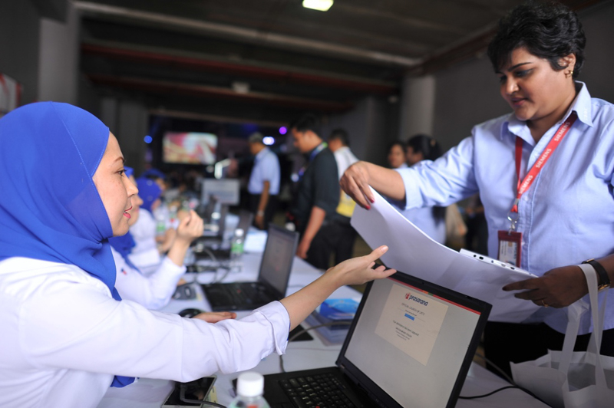

Guest Registration for LRT3 Launch event upon their arrival

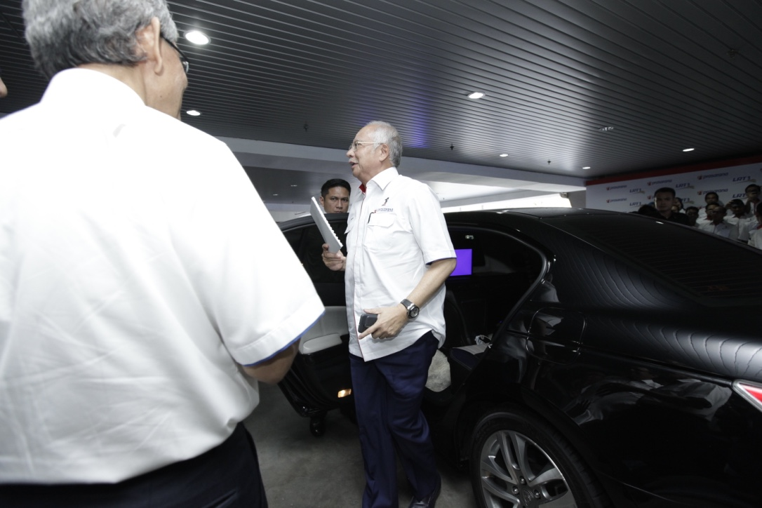
Arrival of Prime Minister, YAB Dato’ Sri Najib Razak

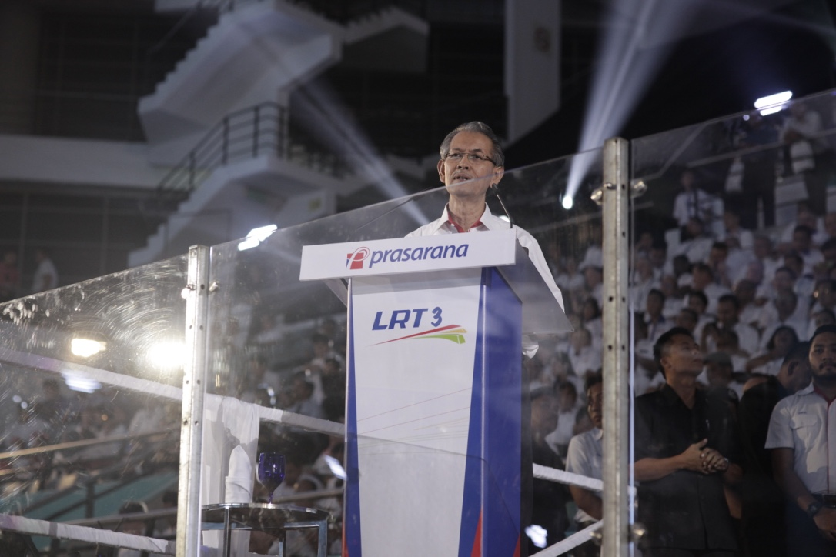
The Chairman of Prasarana, Tan Sri Ismail Adam giving his welcome remark at the LRT3 Launch

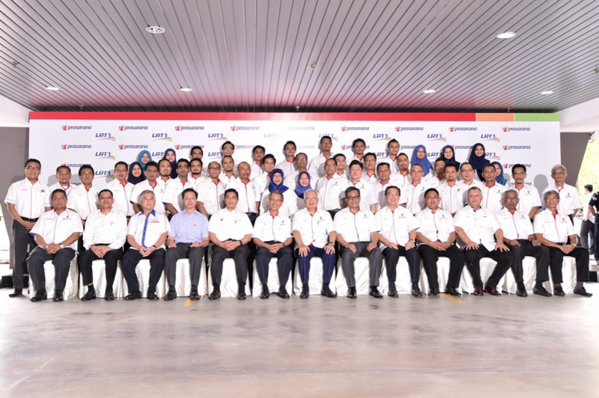
Hon. Dato’ Sri Najib Razak with distinguished guests including the Chairman of Prasarana, Tan Sri Ismail Adam, CEO of Prasarana, Dato’ Azmi Abdul Aziz, Chief Minister of Selangor, Dato’ Seri Azmin Ali, Minister of Transport, Dato’ Seri Liow Tiong Lai, during group photo

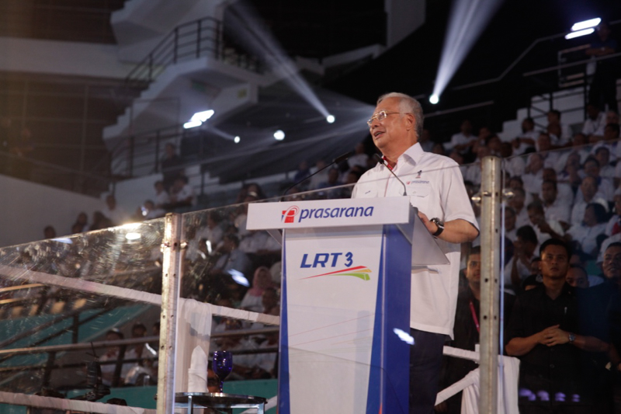
Hon. Dato’ Sri Najib Razak delivering his speech

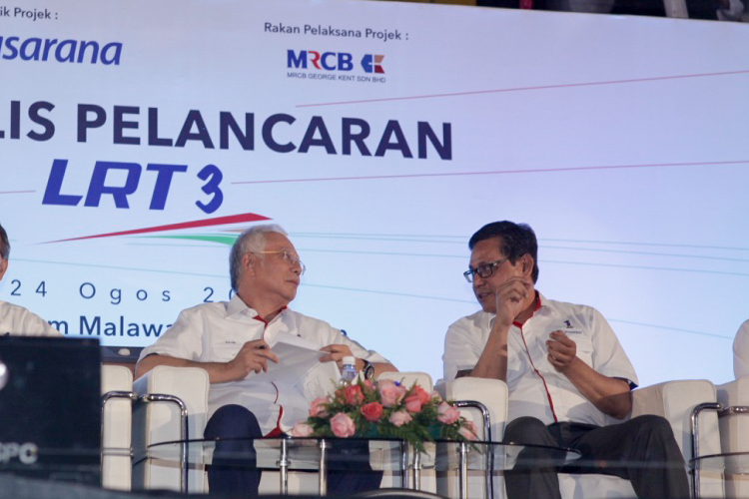
Hon. Dato’ Sri Najib Razak with Dato’ Azmi Abdul Aziz, President & Group CEO of Prasarana

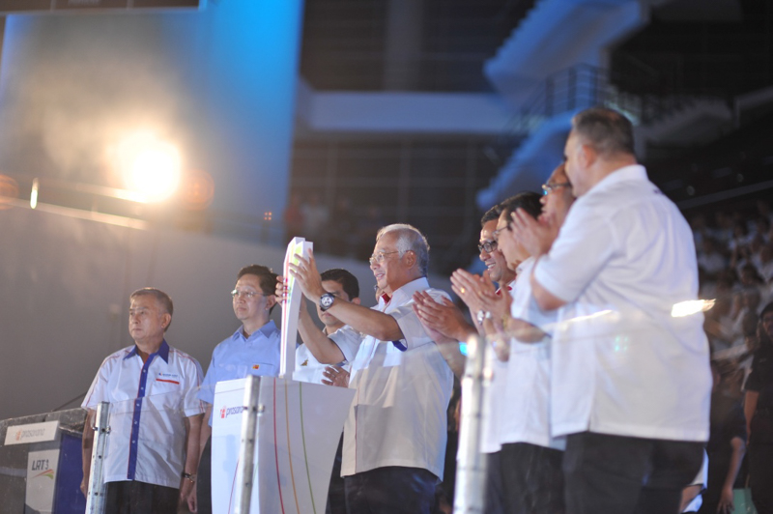
Hon. Dato’ Sri Najib Razak officially launched LRT3 project.

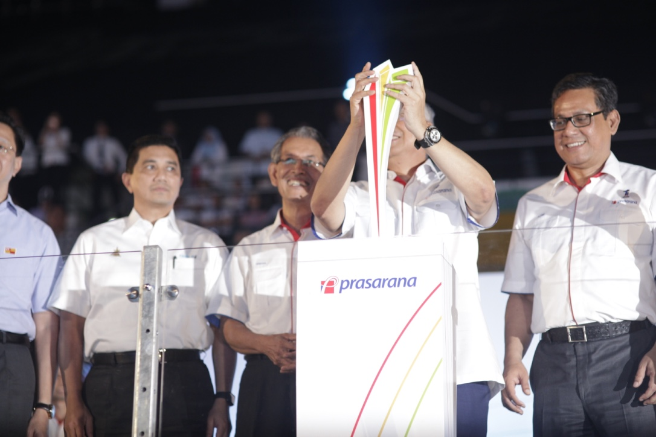
Hon. Dato’ Sri Najib Razak and President & Group CEO of Prasarana Dato’ Azmi Abdul Aziz during the launch gimmick.

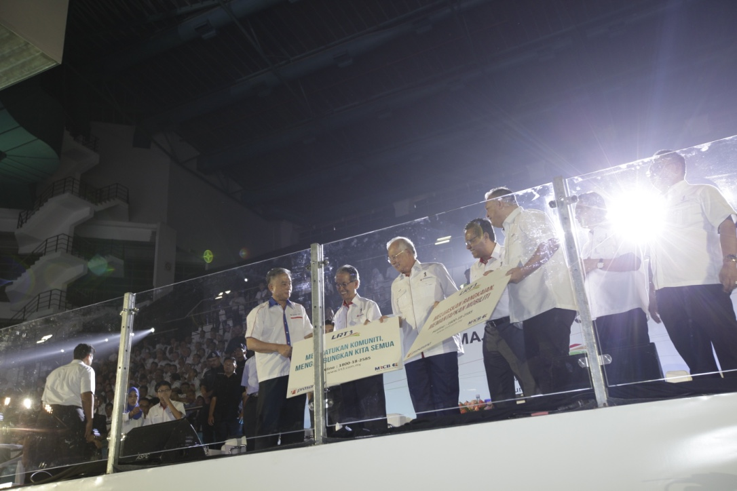
Hon. Dato’ Sri Najib Razak handing over mockup of New Jersey Barrier (NJB) stickers to MRCB’s Chairman, Tan Sri Mohamad Salim Fateh and George Kent’s Chairman Tan Sri Tan Kay Hock.

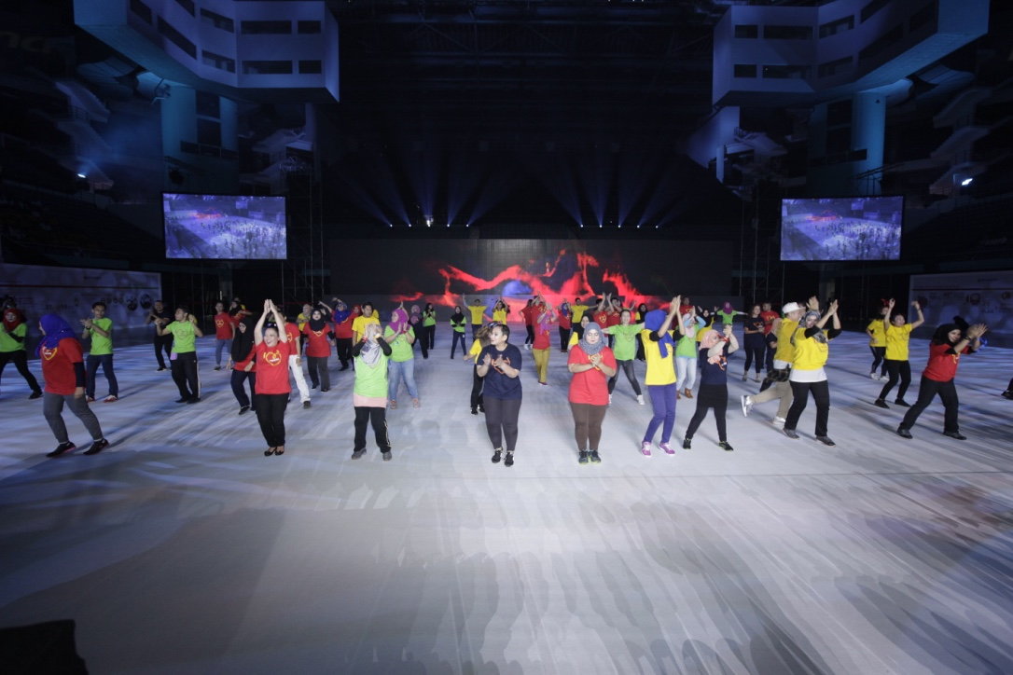
Flash mob performance by Prasarana’s employees.

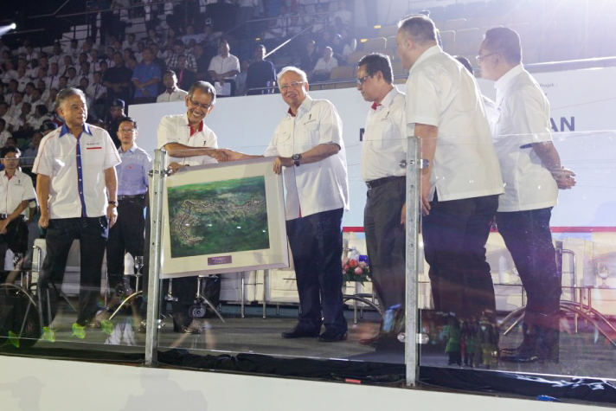
Hon. Dato’ Sri Najib Razak received commerative plaque from Tan Sri Ismail Adam, Group Chairman of Prasarana

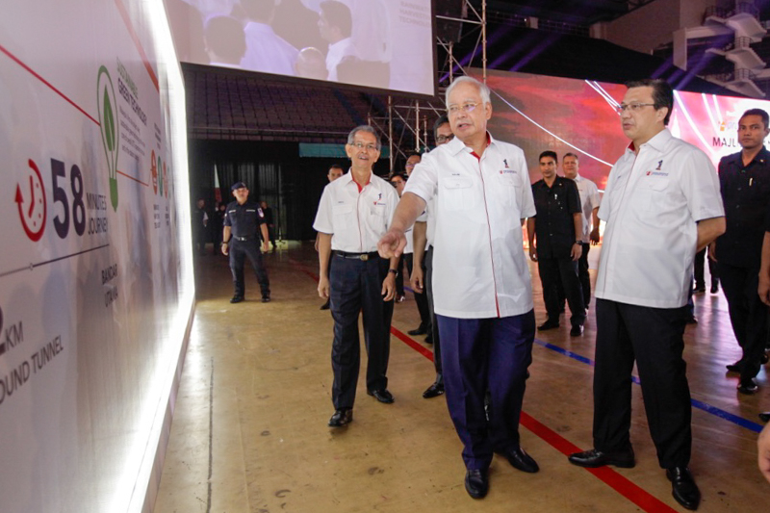
Hon. Dato’ Sri Najib Razak inspecting exhibition showcase with Dato' Sri Liow Tiong Lai, Minister of Transport and Tan Sri Ismail Adam, Group Chairman of Prasarana

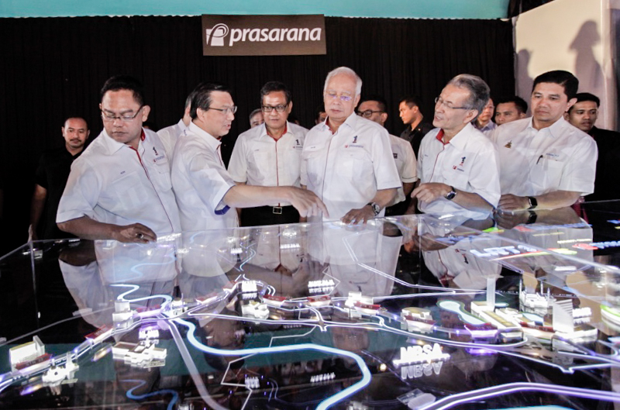
Hon. Dato’ Sri Najib Razak inspecting LRT3’s alignment model with Dato' Sri Liow Tiong Lai, Minister of Transport, Tan Sri Haji Noh bin Omar, Minister of Urban Wellbeing, Housing and Local Government, Tan Sri Ismail Adam, Group Chairman of Prasarana, Dato’ Azmi Abdul Aziz, President & Group CEO of Prasarana and Dato' Seri Mohamed Azmin bin Ali, Chief Minister of Selangor

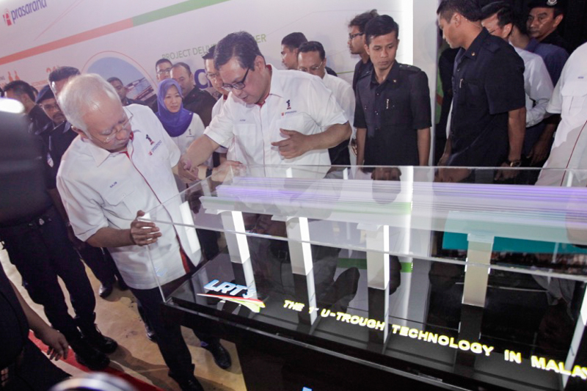
Hon. Dato’ Sri Najib Razak inspecting LRT3’s U-Through technology model with Dato’ Azmi Abdul Aziz, President & Group CEO of Prasarana

